Week03 - Testing Database

SQL to check the tables

Q2. Show the output from two of the adjacent tables in turn – that is orders and item; users and item

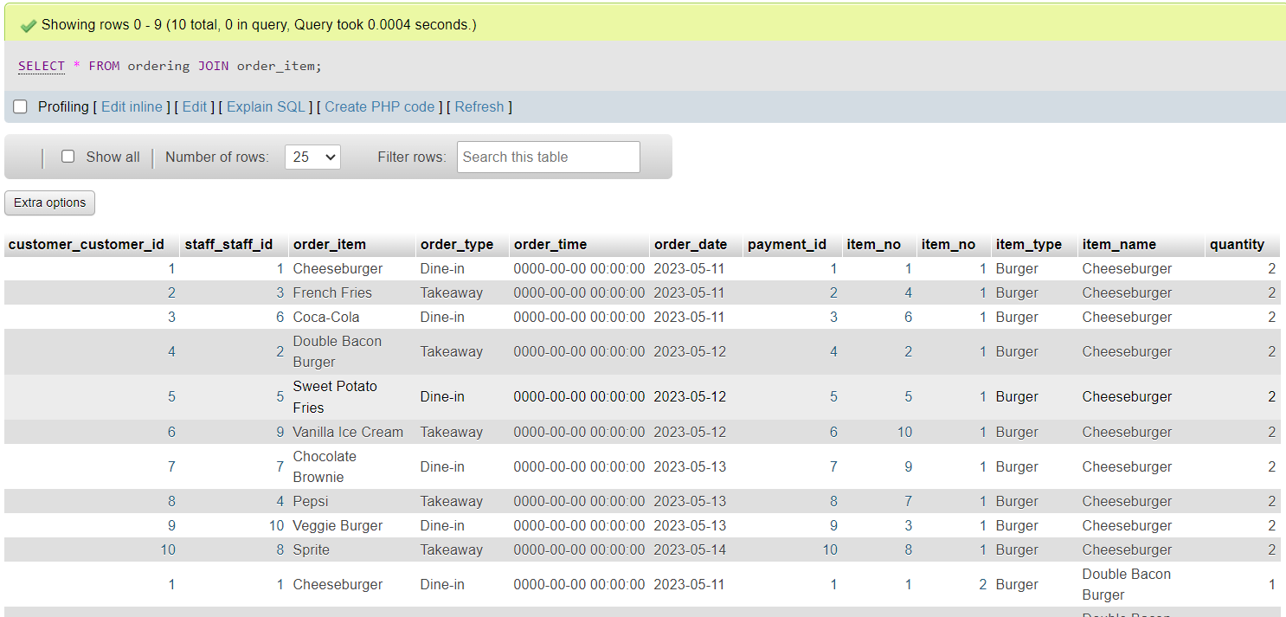

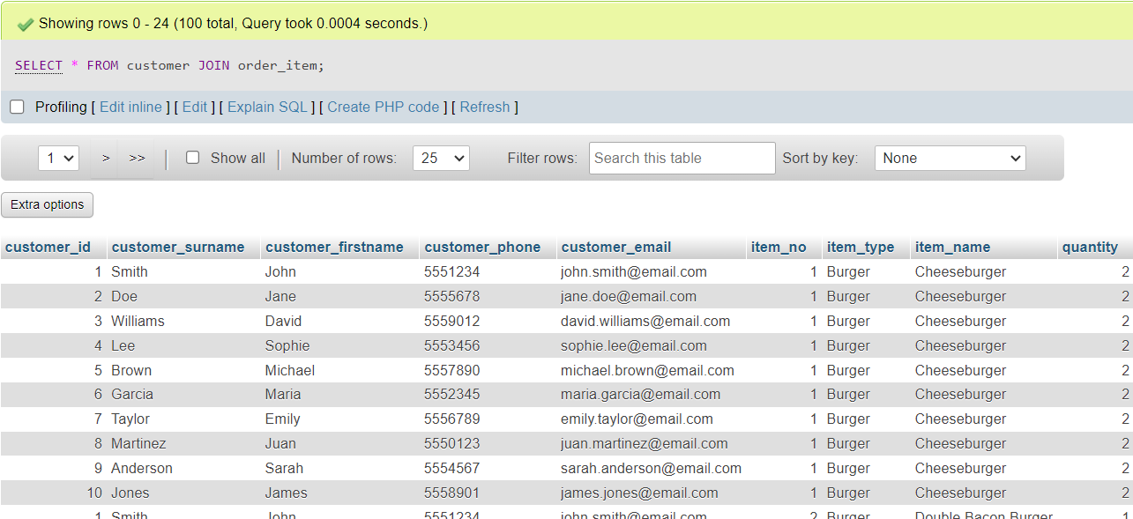

Q3. Connect all three tables and display the output that shows the output from these three tables – customer, ordering and item.

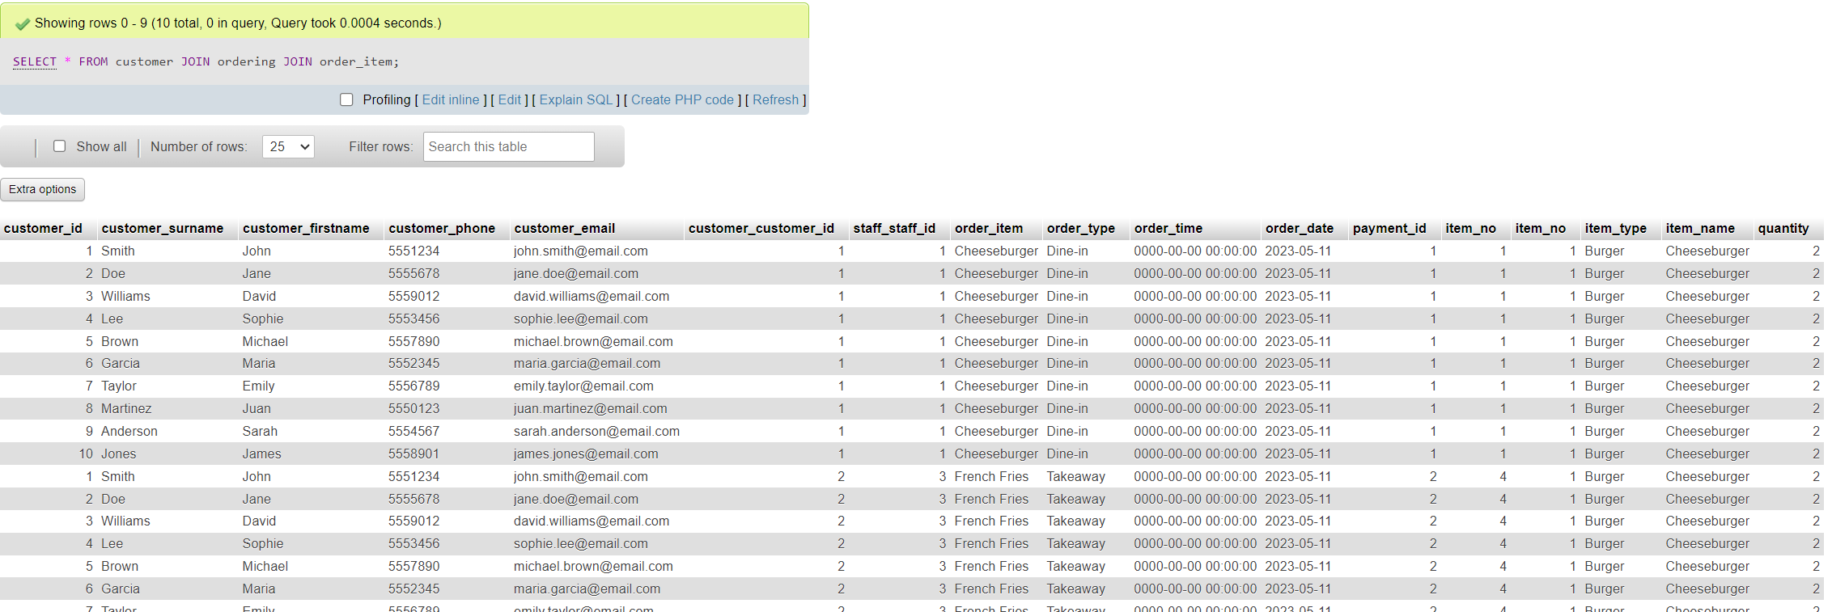

Q4. Create a query that will show the customer and order – so link these two (changed from items to order as cannot link)

Q5. A manager wants to show a catalog of the items in the system – but only the following attributes showing: item_name, item_type, item_quantity (changed again for relevance)